Shota Rustaveli Theatre and Film Georgia State University

Humanities, Social Sciences, Business and Management Faculty

Ekaterine Geliashvili

Ornamental symbolism in Georgian folk choreography

Autoreference
To the dissertation submitted for award of academic
degree of Doctor of Art Science

Scientific Advisor:
Doctor of Arts, Anna Samsonadze

2014
Tbilisi, Georgia

General description of the work

Relevance of the topic: Since the times of primeval societies, eternal perceptions and symbols were visible in all eras, remaining important even up to now. They underlie all spiritual spheres of human activities, including art. Scientific research in this field is linked to understanding this symbolic language, decoding signs, and studying phenomena behind them.

These universal symbols have remained important up to now. Their different forms can be encountered in the choreography of Georgian dances. In the meantime, Georgian folk choreography is a dynamic representation of the history of the Georgian nation known from ancient times.

Subject matter and object of the study: The archaic nature of symbolic signs and their historic stability make specimen of Georgian folk choreography interesting objects of research, where ornamental pictures (dancing steps) and many other elements of compositions have been known since the early period of arable farming. Correspondingly, the geometrical figures used in dances start to bear the coded content of these symbols. Correspondingly, the object matter of the study is Georgian folk choreography (from ancient times to the 20th century) and the subjects of the study are the symbols of the figures that can be seen when dancers move.

Aims of the study: Studying the symbolic forms of dancing steps, it is important to take into account their religious aspects, which is supposed to provide more specifications of the symbols they represent. Regarding this as a whole, we will be able to study all this as a whole, reflecting the conceptions of the surrounding world and their links to the social environment. Correspondingly, this study aims at finding structural links between ornamental symbols and various specimens of Georgian folk choreography bearing the symbols and viewing the symbols as a whole:

- Revealing symbolic forms while discussing and studying specimens of Georgian folk choreography, which is supposed to create grounds for understanding the existing reality and its links to the past;
- Analysing social and religious processes that had an impact on the formation of the ornamental forms of Georgian dances;
- Identifying the ideas, which various symbols were based on at certain stages of popular conceptions;
- Studying specimens of dances in a comprehensive manner (forms, content, themes, ideas, dramaturgy, dancing steps and vocabulary, round dance texts, music, artistic decorations, and so forth);
- Analysing terminology and names;
- Studying the typological features of similar structural forms existing in different regions;
- Decoding the essence of the content of specific geometrical forms in the dancing steps in Georgian choreographic specimens;
- Linking with each other structurally ornamental symbols and various symbolic signs of the specimens of Georgian folk choreography.

Methods and methodological foundations of the study: The comprehensive nature of the subject matter of the study determined the choice of the method of the study. Regarding only the aesthetic angle of symbols cannot bring desired results in the current situation. Such an approach led to the situation, where we took into account the achievements of not only arts (choreography, music, oral folklore, painting), but also other fields. Correspondingly, the method of research covered several fields. In addition to the theory and history of choreography, the study took into account the achievements of semiotics, religion, history, archaeology, ethnography, philology, psychology, philosophy, geometry and other sciences.

Thus, the study is based on the complex interdisciplinary approaches.

A broad spectrum of practical and theoretical materials were used in the study, including special literature as well as fundamental works in history, literature, psychology, ethnography, expeditions, archaeology and others, collections of works, articles, magazines, newspapers, and the global web.

Originality and practical application of the study: Specialists in various fields have studied symbols in an appropriate manner, but not the ornamental symbolism in Georgian choreography. The draught of dances that dancers follow allows us to see various graphic symbols and use special methods to understand their meaning.

The study showed that the symbols expressed in the draughts of Georgian folk dances comprise huge information, which has mythological, cosmogonic, religious, and magic aspects at the same time. In our opinion, their comprehensive study drew us closer to the traces of initial information, which enabled us to shape a completely new vision of high-rise round dances and the content encoded in them (a choreographic model of the universe); the essence of the symbol of strictly ordered rectilinear dances (one line of rectilinear dance is a hyperspatial tunnel, a border between this world and that world, and two lines of rectilinear dance are part of productivity ritual, which distinctly shows two opposed forces (virtuous and evil) fighting each other). The structure and main idea of the dance Khorumi (which is a large system with its choreographic forms and structure that imply the struggle for productivity, establishment of order in the world, and conceptions of the flow of time, all of this being the act of Genesis). We clarified the problem of the direction of the rotation of round dances. In Georgian folk songs, movement in the circle from east to west, i.e. contraclockwise, symbolizes the so-called "movement of the sky" and movement in the opposite direction that of planets. Clockwise movement can have another explanation - movement of the round dance towards the sun, day, and light.

In addition, the study found that the information encoded in some Georgian dances is clearly linked to the Proto-Hittite and Sumerian-Babylonian cultures, which is indicative of mutual ties between ancient Georgian tribes and these great civilizations.

In our opinion, the work is going to be useful for choreologists, choreographs, and students of this speciality, researchers in different fields of arts, folklore, and so forth as the first attempt of looking deep into the ornamental symbolism of Georgian dances. To a certain extent, it is going to play a significant role in further studies into the sphere.

Volume and structure: Ancient civilizations regarded order - κόσμος - as the foundation for the unity of the universe. Circle and straight line were the two ideal forms in this order, which served as a foundation for other figures. For this reason, our work took the following shape: Along with the problem of ornamental symbolism, there are two more chapters - Circle and Straight Line, which include various dancing forms. The structure is as follows:

The work comprises 247 pages. It has Introduction, three main chapters with subchapters, where dancing draughts - ornamental form - of Georgian choreography and key problems of the history and theory of Georgian choreographic art are discussed. The bulk of the work contains appropriate pictures. Conclusion sums up the results of the work. The work is appended by a long list of references (works in Georgian and foreign languages and materials from Internet resources).

Content of the study

Introduction describes in general terms the problem dealt with in the work, its importance, and the current status of research into the problem. It also presents the problem under research as a whole and scientific data linked to choreography that touch on the symbolic content of the draughts of Georgian dances.

Chapter I - Problems of Ornamental Symbolism: The roots of art are lost in the depths of millennia. Its history is the endless striving for perfection. This specific form of spiritual culture that reflects reality in artistic images is conditional itself. Art is based on reality, but at the same time, its spirit becomes unreal. Given this, its conditionality as such implies symbolism. Art as such is symbolic.

The expressive means of every artistic image is also symbolic. The author of a choreographic artistic piece also expresses what he/she has to say and communicates his/her ideas through symbolic allusions of various components. Geometric forms created in dancing draughts which dancers follow, moving and positioning in space, are one of many components (the symbolism of movements, gestures, and artistic images as a whole, as well as that of colours, sounds, and numbers).

What is a symbol and what can its definition be? A symbol (Greek symbolon - "sign", "emblem") is a sign that is linked to the object that it represents in a manner that the content of the sign and its object are represented only by the sign itself and can be explained only though its interpretation. It is a synthesis of general and concrete features. A symbol as a sign comprising a generalized content emerges at a certain time and as public opinion changes, the value of its content starts to diminish. Gradually, the idea represented by a symbol becomes not so topical and the symbol changes its content, not form, becoming visible in cultures and civilizations that are quite different. In such cases, symbols acquire other contents and ultimately, are presented as having purely artistic functions and aesthetic values.

The idea of a circle as a perfect figure has been known since times immemorial. It was on this basis that cities were initially planned. The circle was a sign of celestial bodies and illuminated deities. This ancient mystic symbol that has neither a beginning nor an end is a symbol of the integrity and eternity of the universe. The emptiness within the circle was often filled with various signs regarded as symbols of its eternity.

The circle is the most widespread geometric symbol in choreography. Its smooth and light form can be seen in ritual dances in ancient temples. The main draught of performance - the circle - is, on the one hand, a very convenient and optimal form for a mass ritual dance and on the other hand, it had a symbolic and magic content linked to the cults of the Sun and Moon. In various tribes, round dances were linked to a period prior to hunting and implied supplication to the deity for productivity and success in general. Ritual round dances widespread throughout the world are ancient and they comprise deep mystical symbolism.

Georgian people also were aware of the importance of the circle's mystical symbolism. This form is characteristic of most Georgian round dances, which means that they are ancient and ritual dances. This uniform draught has variations such as several small circles on one big circle, a circle within a circle (there may be two or three circles), an open circle, high-rise circle, and so forth.

Two circles of round dances were also linked to the worship of celestial bodies. Some Georgian researchers explain that high-rise round dances have military content and others point to the solar symbolism of the productivity cult.

As regards the dancer within the circle of the round dance, researcher Avtandil Tataradze noted in this connection that the figure was introduced comparatively later, when it became necessary to use actor's skills to express the content. However, we have another idea, given the fact that something placed within the circle was strongly worshipped. It also had deeply mystical overtones made clear by the institution of preaching and ritual and choreographic actions used. Shamanic practices are as old as the world.

A. Tataradze regards mass dances performed in lines as solemn festive dances. Some researchers believe that the emergence of direct lines in mass dances is linked to the cult of farming and they symbolically reflect the lines that emerge when ploughing. Our theory differs from both opinions and we will familiarize you with it in the following chapters.

The Georgian word linked to dancing - perxuli "round" - is linked to circle, while linear dancing points to dancing on a direct line. The word perkhisa is often used now in this connection, which we regard as incorrect.

Direct line is also an ideal regular form, reflecting borders of segments and the trajectory of a beam of light. Here, we recall the Greek model of thinking - geometric optic. However, direct beams of light are not a Greek invention and the form can be encountered also in ancient civilizations (for example, in Egypt). A direct line is the male principle symbolising infinity, conquest, and competition. There are three factors that determined the emergence of direct line: The initial point, the final point, and the space between them.

As regards rippled and zigzag lines, in the Georgian as well as in Sumerian and Elamite traditions, they are linked to movement and have a semantic meaning of water. The popular understanding of zigzag lines can easily be seen in the Georgian name of embroidered ornaments - tsqalai "water".

Ladder and bridge can be regarded as a certain symbolic reflection of vertical and horizontal lines. They are symbols of connection between spheres that differ from each other. Bridge is a link between earth and sky from up to down and from the bottom upwards. Bridge that connects the two banks of a river is a symbol connecting this world with that world. It is also linked to the horizon line.

The intersection of horizontal and vertical lines produces a cross and the point where they (earth and sky) meet is the centre of the universe. As a rule, the symbolism of cross was linked to the universe, cosmos, and the opposition between sky and earth and time and space. In the very first centuries of the spread of Christianity, the Egyptian hieroglyph anch ("life"), which has the form of a cross, was used as the symbolic icon of the life-giving cross. It was the most important symbol of ancient Egyptians and it was called crux ansata or a cross with a handle. It unites two symbols: cross as a symbol of life and circle as a symbol of eternity. Together, they express immortality. The symbol of spatial cross exists almost in all cultures.

According to the Sumerian myth of the creation of the universe, the determinative denoting divinity - dur-an chi - expresses the link between sky (an) O+ and earth (chi) +. Like Egyptian anch and Sumerian ank, the icon and symbol of Lamaria deity is also called angi. In a Svan ritual, it is driven in the top of murqvami (snow tower). It is noteworthy that this symbol is also a result of the combination of cross and circle (sieve).

Analyzing numbers, V. Toporov concluded that the number "three" is based on the vertical construction of the universe - upper world (sky), middle world (earth), and lower (underground) world. The numerical symbols that correspond to them are "one" - whole, "two" - sky and earth, and "three" - upper, middle, and lower spaces.

As regards the horizontal dimension, three points connected with each other create a triangle. A triangle with its foundation below and its tip upwards is a symbol of mountain. It also points to the aspiration to heights and the sky. Such a triangle is a symbol of the male principle and a triangle with its tip down to the female principle. The former symbolizes fire and air and the latter symbolizes water and earth. Ancient Greeks used equilateral triangles to symbolize wisdom and medieval European craftsmen often used the figure to symbolize the single entity and the indivisibility of the Holy Trinity.

It is noteworthy that various geometric and numerical symbols are more or less linked to the symbolism of colours. In astrology, the seven colours of rainbow correspond to the seven planets that have signs of corresponding geometric symbols. In general, in the majority of the parts of the world, the black colour is the universal symbol of death, mourning, darkness, evil, and negative forces. White is the symbol of celestial purity and light. Red symbolises fire and the sun and is linked to regaining life. White, red, and black colours correspond (in Georgian mythology) to the three vertical spaces.

Since ancient times, people have attached great importance to "reading" colours, numbers, and figures and their symbolism, which was reflected in mythology, popular tales, fairy tales, various religious and mystical teachings, rituals, and, correspondingly, folk choreography.

II – Circular dancing movements and round dances

II – 1. a) Ancient round dances with hunting content. At the early stages of the development of society, the art of dancing had a magic function in the struggle against unclear forces of nature. The "dancing hunt" or the dance of hunters with various contents is part of the choreographic treasury of many nations of the world. Round dances of this content can be found in Georgian folk choreography up to now.

In Svaneti, they still dance the hunting round dance called Dala Kojas Khelghvazhale (Dali Giving Birth in a Cliff). It is believed that this round dance emerged in the era of matriarchate. According to tales widespread in Georgia's highlands (mostly in Svaneti), the protector of wild animals and hunting, Goddess Dali, the werewolf, is a beauty. She lives in inaccessible cliffs, from where her gold hair spreads down. The song accompanying the aforementioned ancient Svan ceremonial round dance, which has a long text resembling a ballad, says that the goddess of hunting, Dali, was giving birth in white cliffs. It also mentions her plait, which she used to raise her child from the root of the cliff, and the gold-horned aurochs. In mythology, tower is the centre of the universe and a holy place and plait, as well as ladder, is the ladder of gods. As regards the colour of the plait and the horn of the aurochs, they are of gold, i.e. the colour of the sun. The horned deer is a constant attribute of Dali as a goddess. Thus, the circular form of the round dance clearly shows its heavenly symbolism. On the basis of the legend, we can presume that this round dance is devoted to Dali, the deity of hunting decorated with astral symbolism.

The myth of Georgian Prometheusm - Amirani - that is encountered in almost all Georgian regions in various versions supports the aforementioned opinion. It is believed to be similar to Sumerian Gilgamesh and Greek Heracles. The choreographic depiction of Amirani that is also circular in form can still be seen in Upper Svaneti under the name of Sanadiro ("Hunting") and in Racha under the name of Amirani Round Dance. There is an opinion that the hero of Georgian national epos has remote links to the Egyptian Sun God Ra and Sumerian Ama ("Mother"), in other words - Son of the Sun. According to researchers specializing in folklore, in some cases, Amirani is the son of Dali and in other cases the son of the Sun. In this regard, A, Tataradze decided that it was necessary to compare with each other the Sanadiro round dance of Amirani, Dali, and Lile, the round dance devoted to the Sun. He found that the combinations of movements in Dali and Amirani were largely the same. They have 14 of 16 movements in common. The similarity is even deeper between Amirani and Lile. There are almost no differences between them.

We encounter similar allusions in the text of the Amirani round dance: A gold-horned divine deer; tower - a cosmogonic symbol, where a knight dwells. According to folklore, the daughter of the astral deity also dwelt there.

Hunter Gergil who is mentioned in the text of the round dance called Dala Kojas Khelghvazhale is also mentioned in the Svan round dance called Lemchil. The text praises the skills of the hunter. The name of the round dance - Lemchil - means "the one, who is to grow old". As we could see at the master class of Svan dances, the aforementioned round dance, like other round dances described above, are circular.

It is noteworthy that this round dance has the main figure in the shape of a hunter, the imaginary central figure of the circular round dance, which consists of two parts. The first part is comparatively slow and the second part is quick. Both parts of the composition retain the circular form and a number of dance movements.

There is another round dance in Svaneti that is similar to Dala Kojas Khelghvazhale in content. It is a round dance Metkhvar Mare praising Goddess Dali and Apsati.

In Georgian myths, prominent hunters are Dali's or Tqashmapa's lovers. This is a precondition for their success. However, as a rule, hunters try to avoid the love of the shepherd of beasts. The hunter, who saved Dali's son, behaves in the same manner and the deity holds him responsible for the behaviour: The arrow he shoots on a gold-horned deer returns to the shooter. By failing to observe the sanctity (headscarf), Betkil de-sacralised the deity. This is the main idea of a hunter's round dance of the anthropomorphic era Bail-Betkil that is performed in Svaneti up to now.

The Samtis round dance mentioned in the text of Bail-Betkil is also noteworthy. In the Svan language, it is called Samtis Chishkhash, but we know nothing about its content and we do not have its description. In our opinion, the name Samtis Chishkhash is indicative of the fact that it was a ritual round dance performed on a mountain. In addition, the text says that a white ram "came down on the middle of the round dance", which implies that the round dance could have a middle part in case it was circular. The emergence of a ram in the middle of the round dance points to the fact that it was an object of worship. The white ram is a hypostasis of Dali. As regards the mountain, it is a symbol of the axis of the universe. Given this, Samtis Chishkhash can also be regarded as a round dance praising Dali. Disruption of a circular form, i.e. round dance, was a sign of something bad (just like in the Korbeghela round dance) and correspondingly, the end of the story is tragic.

There is a wedding tradition in Meskheti called Groom's Hunting. There are also dances and songs linked to this tradition, which we think has roots in the remote past. From the choreographic viewpoint, it is noteworthy that the ritual comprises a round dance after the groom's return from a hunt. (The dance was performed on the earth roof or in the yard before entering the home.) Some narrators regard the performance of "Seven Pairs of Round Dances" as part of Groom's Hunting. The name "Seven Pairs of Round Dances" makes it clear that seven pairs of dancers performed the dance. The number "seven" plays an important role in Georgian beliefs and can often be encountered in various dancing moves. "Seven" is a sacral number of perfection and completeness and the circular form of the round dance resembles the Sun and the Moon - symbols of celestial perfection.

On the basis of the materials we found during the research of the problem, we concluded that circle as a symbol of deity existed in hunters' round dances in ancient Georgia.

II – 1. -b). Ancient circular round dances glorifying the Sun and the Moon. Like the ancient East, the Sun and the Moon occupied first place among astral deities. The Sun was believed to be a goddess (Mzekala, Barbale) and the Moon a god. In the remote past, numerous rituals and traditions of the nations of the world were linked to astral cults.

To express respect for the Moon, Lamproba (lamp-lighting) was celebrated in ancient Georgia in early spring. The ritual has been preserved in Svaneti up to now. The ritual was meant to request the wakening of nature and the coming of spring. Participants in the ritual built a fire at the end of winter, glorified the deity with lit torches and performed a round dance with celestial torches in their hands In Upper Svaneti, Lamproba was also called Svomonoba. It was part of the celebrations of the Kviria cycle held in early spring and was performed as Svan Berikaoba-Keenoba. Participants elected a "Caesar", his "wives" and "viziers" and took ritual round loaves to the temple, where they drank communion wine. From the temple, people went to the house of the family hosting the community, where they sung hymns, walked around the hearth with lit candles, and engaged in wrestling and snowball-throwing, and performed the Lampruli round dance.

Lamproba, a hunter's dance, is described in the 14th-century document "Regulations of the Royal Court", which says that it was performed on a Monday in January, "on the birth night of the Moon". During the performance, people marched with lit lamps in their hands towards the king, congratulating him, his family members and noblemen on the holiday and receiving from them rewards for bringing good news, which was followed by a show that comprised ritual and secular songs and dances.

The ritual fire and the circular round dance and hymns (glorifications) performed around it as described in the document of the 14th century enables us to conclude that the aforementioned tradition is ancient. The fire that is presented as the centre of the circle in this case can be the so-called holy flame, a symbol of the Sun, which could not be seen during the ritual performed in the middle of the night under the young moon. Such rituals are characteristic of ancient pagans. Ancient priests on the Olympus lit the fire in daytime with the help of sunbeams, glorifying Apollo with round dances and hymns. This ritual devoted to the Moon and widespread throughout Georgia was obligatory, as it was known from ancient times that cosmic changes (young or full moon, sun and moon eclipses) had a major impact on the well-being of not only humans, but also the whole world.

Georgians paid much attention to events linked to the solar cycle. Traces of Georgians worshipping the Sun and ritual services devoted to it can be seen in Homer's Odyssey. "The ship Argo came to the isle of Aeaea, where dwelt Circe and where there was a round dance hall of Eos born on the dawn and where Helius (Sun) rises". It seems that Aeaea-Colchis was the country of the rising Sun for Greeks, because it was situated in the east. People there worshipped the Sun and built special halls for it.

The worship of the Sun can be seen in the Georgian folklore in the shape of the circular round dance Lile. It is a Svan ritual hymn and one of the most ancient examples of the Georgian choreographic, musical, and verbal folklore. It is performed by young men and women against the background of a three-voice song with the 6/8 musical time. There is a report that singing Lile, Svans stood facing the east and did that, as a rule, every day. It is true that, after Georgia adopted Christianity, the text of the song was changed, but nevertheless, Lile comprises ancient religious and mythological symbols. This is confirmed by words found in the text, such as "surrounded by a barrier" (in ancient times, people thought that the universe had a barrier as a boundary), "gold pillar" (a symbol of the Sun), "cups" (ritual drinking vessel), "fortress" (a cosmogonic symbol as the centre of the universe), "hawk", "aurochs", "bulls", "rams", "horns", and holy beasts as the hypostases of deities. Correspondingly, Lile is a religious relict devoted to the cult of the Sun. That is why the aforementioned round dance is circular.

The two-circled form of a round dance symbolizes the movement of the Sun and the Moon. As regards round dances with three concentric circles moving in different directions, they symbolize the whole universe - moving sky, luminaries, and stars. This is a form characteristic of Gurian and Ajarian round dances that are still performed in the scenic choreography (Gurian round dance with pairs of women performing and Khorumi), whose roots are to be sought in the astral world.

II – 2. Mystical round dances and dancing movements with objects within circles

a) Circular movements in the times of illness. Special rituals were performed in Georgia in the times of illness or any fortunate or unfortunate happening. Ancient Georgians referred to contagious infectious diseases with a common name of batonebi ("sirs"). People believed that it was necessary to perform various ritual actions to please the "sirs". So "sirs" would be surrounded with special gifts like white coins and white goats and kids, which were then painted in red and decorated with red ribbons. The sick person's mother - "the priest of the sirs" - and relatives moved around the sick person. Women in red or white, who wore dresses with unbuttoned front or were completely naked and danced and sang songs. Women dressed in the aforementioned colours could also move on their knees. Some of them bore on their necks yokes made of vine, twigs or iron, holding lit wax candles in their hands or lit oil lamps on their palms. At the same time, others in the house sang sweet songs like Iavnana, Batonebi, or Sabodisho and danced a round dance.

The colours of clothes in the ritual are noteworthy. The red colour symbolizes fire and the Sun. Lit candles are also linked to it. In old times, idols were often painted in red in order to emphasize their force and astral nature. It is also noteworthy that the red colour symbolizes regaining life. The perception of this colour is also purely psychological. It can give rise to certain sentiments and have an impact on physiology. It is widely used in colour therapy. As regards the white colour, it symbolizes light, the Sun, purity, salvation, and sometimes death.

The accessories and utility property used are also important. The vine and iron yoke on the neck are cosmogonic symbols. In the highlands of Georgia, illnesses were regarded as the wrath of icons, so people entreated them to cure sick people and bore the yokes of icons as a sign of service. Archaeological findings show that such yokes were also widespread in the Bronze Age.

Making research in the text of the hymn Iavnana, Ivane Javakhishvili worked on many versions of the Georgian text and compared it with a reflection of a Babylonian amulet (See picture 1). The compositional structure of the amulet is noteworthy for us. A sick man is presumably shown in the middle frieze with priests moving around him, probably exorcizing. Judging by their line of movement, the priests are moving in clockwise order. On the same frieze, participants in the ritual on the right are moving, hand in hand, from left to right. The figures seen in the upper line are moving in the opposite direction. Presumably, these are seven evil spirits of the "sirs". (The Georgian hymn says: "Seven sirs and brothers spread over seven villages".) The position of their hands is harmonious and synchronic, which means that they are dancing. Their faces are turned to the left. The aforementioned position is similar to a movement in the contemporary dance Samaia. At the end of the movement, the hand moves diagonally from the third position to the fourth, accompanied by the movement of a leg similar to rond de jambe parterre. It is noteworthy that the tune of Iavnana is used in the aforementioned dance.

Various birds and beasts, i.e. sacrificial animals, and naked women can also be seen in the ritual of the "sirs". In the bottom line of the amulet, we can see a naked creature on its knees with a beast's head and bird's claws (nursing the animals). This must be the deity of earth and the Sun. There are divine astral signs above the seven figures in the amulet, which is yet another allusion to the astral nature of the cult. The comparison of the two sets of materials showы that they are similar and of ancient origin. They also show the function of the compositional arrangement of the whole ritual. The latter must be conditioned by mystic actions around the central figure (people moving around him and protecting him) and the presence of anthropomorphic deities decorated with astral symbols.

II – 2. b)The institution of chosen figures and circular actions linked to it. The experience of humanity's remote past and mythological models and symbols are accumulated in shamans' rituals. In Georgia, there are remnants of shaman's rituals in the shape of prophesying, icon soothsaying, or being held by an icon. It is noteworthy that dancing was necessary for such magic actions together with a special environment. In this context, dancing was used as something imparting common energy and causing a religious trance. It is known that since the Palaeolithic Age, the dance of this function has had a circular form, because it was believed that a round dance (shamanic force) produced a powerful energy field. Rusudan Tsanava noted that since the Palaeolithic Age, all residents in various regions of the world without exception performed round dances - eoxors - to gain more force. The term eoxor was borrowed from Old Turkish and denoted "elevation", "inspiration".

Shamanic elements can be seen during the holidays of White George in Atskuri. Various magic actions are performed there, including a circular round dance with one person dancing within the circle, movements around the circle, the colour of the costumes of participants, contacts with the earth, and many other components, which enables us to conclude that this an ancient ritual mystery with cosmogonic overtones.

The comparison of the aforementioned holidays and rituals performed by pagan soothsayers unveiled a number of common features, which enables us to say that an ancient myth about the creation of the universe was performed at the White George holiday in Atskuri and the circular movements of the round dance performed had cosmogonic and magic overtones.

Minute research in shamanic rituals may clarify problems in choreography such as the function of various positions and movements of hands and legs, movement of dancers into the circle and out of it, the direction of circular movements in round dances, and so forth.
Other Georgian round dances of the same form must be indicative of a magic circle and an object within it that should be protected. Circular dancing movements like Dato, Datuna, and Datvobia, round dances Dzabra, Chemo Kurshao, Shavlego, and others probably have roots in the mystic and astral circular forms.

As regards the semicircular form of round dances, we think it must be a variety of this form. We presume that it is characteristic of dances that emerged in a later period than round dances devoted to astral cults, as Georgians performed rituals devoted to the Moon also in the form of the full Moon. According to explanations by a researcher in symbols, I. Surguladze, the lack of semicircular symbols in the Georgian ornamental space could be a kind of response to Muslims.

We assume that circular round dances acquired a semicircular form after passive viewers (not those, who participated in the action) emerged in order to make action within the circle better visible for them.

II- 3. The symbolism of "high-rise" round dances. Unique round dances in circular layers were widespread almost everywhere in Georgia (See picture 2). In Kartli, they were called Zemkrelo/Orsartula, in Javakheti Samkrelo/Tsikhebuna, in Racha Maghla Mtas Modga, in Khevi Abarbare, in Tusheti Korbeghela, in Svaneti Mirni(n)kela (the same as Mirmikela, Mirminkela, Moril-Mikela). The Georgian dance folklore still has the Gurian-Ajarian round dance named Orsartuliani Perkhuli (Two-Storeyed Round Dance) that can be seen in one of the parts of the dance Khorumi. A round dance called Madli Makharoblisa was widespread in Imereti, but unfortunately, no description of the dance is currently available. There is information that a round dance that was linked to Vakhtang Gorgasali and was mostly widespread in east Georgia was also known in Imereti. Some of these round dances are still performed by Georgians.

Researchers hold various opinions on the symbolic content of high-rise round dances. Some believe that they are military dances and others point to their function of worshipping the productivity cult.

On the basis of comparison between the aforementioned dances, we think that high-rise round dances with their astral symbolism are directly linked to the productivity cult, which is supported by some signs found in their structural form, names and texts: 1. The name of the round dance in Khevi - Abarbare - directly points to its link to Sun-Woman Barbare, the protector of light and productivity. The round dance implies that people asked Barbare for rain to ensure a good harvest. 2. Korbeghela in Tusheti was performed near the icon. Performing it, local residents tried to explore their own future. Korbeghela is a ritual dance, which is confirmed by the text of the song. The dance is a symbol of abundance, multiplication of cattle, and productivity. 3. It is important that beer is present in the round dances of Khevi and Tusheti as a drink of cult. 4. The Gurian-Ajarian Khorumi was also performed at wedding parties. The name of the dance is obviously linked to Ajarian-Laz dwelling house a-khor, o-khor, which as a storey in an Ajarian house, is functionally linked to the winter stall and, correspondingly, a tuft of hay ("khoromi"). Therefore, the name Khorumi, like Korbeghela, is a symbol of abundance, multiplication of cattle, and productivity. 5. The Svan high-rise round dance Mirminkela was performed on svipi (holy square) near the holy lime tree, which is a symbol of life. At the same time, it was part of a ritual glorifying Kviria (productivity). 6. The fact that three-storeyed Samkrelo was performed in a productivity ritual and Berikaoba in Meskheti points once again to the link of these round dances to the productivity cult. 7. According to Professor Lili Gvaramadze's explanations, the text of the Madli Makharobeli round dance reflected the struggle between the winter and the spring. 8. It is noteworthy that the Zemkrelo round dance is also devoted to productivity and celestial deity, which is confirmed both by the name and the text of the song that mentions wheat, barley, sun, and snow, which a clear confirmation of the aforementioned. The latter has a parallel in the Svan Murkvami tower devoted to the deity of productivity - Kviria. If we are guided by the cosmogonic views of Georgians, the name Zemkrelo is linked to cosmic symbolism and the upper and lower storeys of the round dance may symbolize the sky and earth (see Diagram 3).

In our opinion, the spatial structure of circular round dances is similar to the cosmogonic views of Georgians. It is the same as the spatial structure of the universe like that of residential houses, houses of worship, and residential and defensive towers. This form of round dances was a means of contact and communication with the sacral spheres of cosmos. To put it in modern terminology, high-rise round dances are a variety of imago mundi. Their choreographic form is supposed to restore the link between the sky and earth. Our presumption is supported by the cosmogonic worldview of Georgians, which fully defined the perception of archaic people (spatial terms still remaining in the Georgian language, archaeological monuments, cryptographic images and so forth). The aforementioned is confirmed at the global level in works by prominent historian and researcher in mythology Mircea Eliade. We presume that high-rise round dances are a model of the universe as imagined by Georgians. The link between the sky and earth is restored in them in a choreographic form, which reflects the harmonization of chaos in the sacral space (see Diagram 4).

We have the following explanation of various perceptions of one symbol, which, as researchers believe, implies various contents: It seems that we are dealing here with the fading of a symbol as a unified sign. According to myths, it was necessary to struggle to achieve productivity. When the initial content of a symbol (the deity of productivity) lost its importance, only struggle remained in it (given Georgian historical and political past). Ultimately, the only function it retained was entertainment. In the meantime, the form remained unchanged given the features of the symbol.

II – 4. The rotation and movement of the circle. The study of Georgian round dances and dancing movements has shown that circular round dances move in different directions. Clockwise movement is particularly frequent. This direction is often regarded as positive movement. Pagans move around the fire in the same direction. In the annual Kaaba ceremony, thousands of faithful Muslims walk seven times around the sacred object in the counter-clockwise direction. According to the rules of the Moscow Patriarchy, the religious circle (litany around a church and round movements during a wedding) are done in the counter-clockwise direction (like in Georgia), while Old Believers (Starovers) and Catacombs Christian moved in the clockwise direction. Even today, the ritual of moving around a dead body is performed in the counter-clockwise direction in our country.

It is known that in ancient Egypt, priests performed astronomic dances that reflected the harmonious nature of celestial bodies and rhythmical movements of the bodies in the universe. The dances were performed around sacrificial altars in temples. The altars that symbolized the sun were erected in the centre of the temples. One of the dances was described by Plutarch. He said that at the beginning, dancers moved from east to west, symbolically expressing the movement of the sky, and then they moved from west to east to symbolize the movement of planets. Using different kinds of movements, priests symbolized the harmonious nature of the universe.

We believe that in Georgian folk dances, the movement of the circle from east to west, i.e. in the counter-clockwise direction, was the so-called "movement of the sky", and the movement in the opposite direction that of the planets. There can be another explanation to the movement in the counter-clockwise direction: The circle of a round dance moves to meet the sun, day, and light (See picture 5).

Experiments carried out and conclusions drawn by psychologist Leonid Kitayev-Smyk are also noteworthy for the purposes of this study. The researcher drew conclusions on the impact of round movements on the psychology of people.

Chapter III - Linear compositions
III.-1. Group dance, row - the problem of the choreographic form of the terms. It is noteworthy that non-circular round dances that are often linear are called perkhisa in Georgian. Perkhisa and perkhuli (round dance) as terms have different meanings in special literature, but they are often identical in use in folklore and the colloquial language.

The link between perkhisa on the one hand and religion and productivity cult on the other is confirmed by the fact that the perkhisa described by Teimuraz II was performed during the festivities held in connection with the birth of a son. The perkhisa called Jvaris Tsina was mostly performed at wedding parties in various regions of Georgia. Vakhushti Bagrationi also confirmed that perkhisa was a religious action. Speaking about the term perkhisa, some scientists emphasize its geometric form.

The conclusions researchers have drawn differ. They point to perkhisas that are linear performed in one line (G. Chelidze), linear performed in two lines opposing each other (Janelidze, Tataradze), performed in multiple lines, performed with dancers on an arc-shaped line (Tataradze) and combined linear and circular at the same time (in the highlands of east Georgia).

Presumably, unlike round dances, the aforementioned term is not at all linked to the dancing draught and a concrete geometric form. As Sulkhan-Saba Orbeliani explained, perkhisa is "many people dancing in close sequence", i.e. a ritual dance performed by many people. It makes no difference what form the dance has. At the beginning, it may be linear and become circular or winding as dancers continue to move. The form depends on whether dancers had to move around an object of worship or along a line going up and down. Orbeliani's definition also points to the position of dancers. Dancing in close sequence is a direct indication that: 1. Dancers standing one behind the other touch each other with their hands or 2. Standing side by side, dancers move (in a certain direction) holding each other by the hand.

Correspondingly, saying that a specific dance is a perkhisa, does not mean at all that the form of the dance is specified. In such cases, additional explanations are necessary to point to the ornamental form of the dance, which is not true of the term mtskobri. It is an old Georgian term denoting a dance with a specific position of dancers standing in rows. In other words, it implies a direct indication to the linear form of a dance.

III. - 2. One-line linear perkhisis
a) One-line linear perkhisis on archaeological monuments. The choreographic form we are studying can be seen on the Nabaghrevi belt (bronze, 8th-7th centuries BC, Nabaghrevi, Mtskheta District; see picture 6). Some studies say that scenes seen on bronze belts were devoted to the deity of productivity. There is no doubt that people in masks, who perform sacral actions, are dancing a mtskobri perkhisa. This opinion is supported by the rhythmic movements and positions of dancers seen in the upper right part of the belt. The right leg of every dancer is set forwards and they are touching the shoulders of the people standing in front of them with their left hands. The faces of the dancers are turned to the centre. The horns of a deer that can be seen in the middle line seem to be the central symbol of the composition. Deer is a hypostasis of the deity of productivity and its horns a symbol of a sacral tree. In addition, a hand-in-hand battle of people can be seen in the lower right line of the belt. Wrestling and struggle are indispensable parts of the productivity ritual that constantly accompanies the act of the renovation of the world. Scenes of a sacral struggle between animals can also be seen on the belt.

The same chapter deals with belts as spatial objects. The symbolism of belts as magic objects becomes even more evident when comparing Georgian and Russian ethnographic materials. Belting a person expressed his/her transitional status. It was also an accessory of life after death, ensuring a connection between the worlds of the living and the dead. The ritual removal of a belt was necessary when a person moved from one modality to another, which means that the change of modality did not take place in a circular form, as the belt was to be unlocked and it immediately acquired a linear form. Given these materials, the opinion expressed by N. Abakelia on the structural connection between Georgian circular round dances and the form of labyrinth does not seem well-founded.

The jar found on the site of the former settlement of Samadlo (1st millennium BC, see picture 7) bears figures of four men moving in the clockwise direction. The right arm with spread fingers of the man standing at the head of the four is more bent at the elbow than with others and is positioned higher than the arms of the others, which may point to the fact that he is the leading figure in the perkhisa and that the picture may be a description of a mtskobri form of the dance. The fact that this dance is depicted on a jar containing a cult drink is yet another indication of the ritual function of Georgian dances and the connection of this specific choreographic form with the productivity cult.

The ritual silver cup discovered by archaeologist B. Kuftin in Trialeti plays a major role in the studies of the history of Georgian folk choreography. The cup is believed to have been made in the 2nd millennium BC (see picture 8). The description of the picture on the cup and the scientific analysis made by researchers (B. Kuftin, Sh. Amiranashvili, P. Ushakov, N. Japaridze, V. Bardavelidze, M. Chikovani, D. Janelidze, I. Tsitsishvili, L. Gvaramadze, A. Tataradze, A. Gelashvili, and others) provides grounds to believe that this is a ritual devoted to the revival of nature and the deity of productivity. All researchers are unanimous in noting that there are almost no differences between the positions of figures, their profiles and clothes. The figures wear similar masks, they hold similar cups in their right hands, all of them have tails, and wear similar shoes with curled tips. The fact that the participants in the ritual do not differ in anything can be explained by their loss of individual features characteristic of this world. At the same time, none of them wear ritual belts just like the "Nabaghrebi dancers", which means that they are unprotected and are moving to another state.

As regard the animal masks and tails, researchers differ on their implications. Correspondingly, they can be united in one word - predators, mostly foxes, wolves, or dogs, which makes it clear that the ritual is indeed devoted to the deity of productivity. The three animals are hypostases of the deity of productivity. The actions of masked creatures in this ritual are also important for us. Choreographically, they are very similar not to the hunter's circular round dance, but to linear perkhisas with people standing one behind the other.

Most researchers point to their connection to a Hittite deity and ritual. Hittite Telipinu was born as a result of a sacral marriage. He is a mortal god, who can be revived after death. He personifies new nature. The deity of thunder, Taru, is his father and the deity of earth (underworld) and the sun is his mother. The latter has several images and names in the pantheon of Hittite deities. It is also noteworthy that the sacral marriage of earth and sun is the key notion in the religion of farmers. We encounter such marriages in the ancient Mediterranean region and ancient religions of Europe and Asia. This sacral act (in which rain fertilizes earth with water) gives birth to the revived fruit of nature like Telepinu, which literally means "powerful son". The mother deity of the sun and earth is a woman in ancient Hittite religion like in Georgia and the Babylonian pantheon.

As regards Goddess Dali, who some researchers point to when describing the cup, it is indentified with Morning Star and Ishtar and often with Great Mother - Nana (the same is true of the Hittite pantheon). The cult of mother deity was the most ancient in Mesopotamia. In addition, the Sumerian pantheon also comprised the cult of Dumuz (Akkadian Tammuz), the deity protecting grains. Dumuz was a god, who died and revived. He was worshipped as a personification of nature that was always alive and constantly remained in the process of renovation.

Studying the Trialeti cup, researchers point to certain thematic and compositional similarities with the Uruk alabaster vase. This latter was found during the archaeological excavations in the Goddess Inanna Temple and is now kept in an Iraqi museum. The cup is dated approximately to the end of the 4th millennium BC and the beginning of the 3rd millennium BC (see picture 9). We can see the object we are studying on this item, too. We can also see such harmonious figures on Sumerian-Akkadian seals. It seems that the choreographic linear draught with performers standing one behind the other is the main form of the ancient Sumerian ritual movement. The form we are studying is also similar to the well-known rock-cut Yazilikaya relief near the village of Bogazkoy, Turkey (see picture 10). (Earlier, it was close to Bogazkoy that the capital of the Hittite Kingdom, Hattusa, was situated.) Like the Trialeti cup, the object is also dated to 2nd millennium BC. It shows a parade of 12 people, who are believed to be struggling deities of underworld. They wear Mesopotamian horny hats that were a sign of divinity.

Although the objects found in the burial mounds in Trialeti are very similar to those discovered in the southern parts of Mesopotamia, Asia Minor, and Mycenaean Crete, B. Kuftin, O. Japaridze, and others regarded the cup as an item produced locally.

In our opinion, the Trialeti silver cup shows a ritual devoted to the productivity of the universe, which is to a certain extent similar to the Hittite Telipinu and Sumerian Inanna-Tammuz myth. We think that the main figure in the centre of the ritual is the main deity of the sun and earth - Great Mother Nana. The composition and the ritual are devoted to the return of the god of productivity (according to the Hittite ritual, his descendant) from non-existence. The circular form of the cup points to the fact that the myth is about the universe. Major figures in the ritual are dancers wearing animal masks, but no belts, which means that they are heading to the other world. Like the participants in the ritual depicted on the Nabaghrevi bronze belt, they are standing behind each other, heading towards the main deity and the tree of life, which is directly connected to the allusions seen in Georgian choreography to be discussed in the following chapters.

III – 2. b) One-line mtskobri perkhisas in folklore. This subchapter deals with the round dance Melia Telepia, which is part of the Murkvamoba ritual. This holiday marked with wild savagery is known as Adrekila and Melia Telepia in Lower Svaneti and Sakmisai in Upper Svaneti. Rapiel Eristavi wrote about Melia Telepia in his comments published back in 1897. This holiday is described in detail in a work by E. Gabliani. S. Makalatia and R. Chanishvili also wrote about it.

One-line linear dances "O, Hoi, Nano", "Ialis Tamashoba", "Bastis Chabma", "Dighmuri Sakortsino Tamashoba", "Dzaghluri", and "Khorumi" as well as ritual dances performed during mourning and work also have a similar form.

The comparison of the dances reveals a number of similarities: 1. All of the dances were performed at the time that points to their connection to the deity, protector of productivity and fertility; 2. The dances have leaders, who hold in his hand a whip, belt, twig or stick. In our opinion, the leader of the dance, who has major force, strikes a dancer with the whip or stick, symbolizing his death and revival with new reinforced potential; 3. Stripping and then putting clothes on - these signs of worship of the deity of sexual love and fertility probably point to the return of dancers to their initial state and then back to this world. As regards tearing off one's own clothes, which can often be seen in the rituals of vegetative deities, it may be indicative of humans taking products and using them for their own benefit. Putting on black clothes and covering bodies in soot was a trick aimed at deceiving dark forces; 4. The names of mtskobri perkhisas are linked to the productivity cult and the restoration of light from darkness and life from death (See picture 11): Ohoi Nano is an act of imploring Great Mother. The name Iali seems to be derived from the Arabic word yallah ("O, God!"). It was used instead of Georgian O, God! by the multiethnic population of Tbilisi. Dzaghluri ("dog-like") is not an accidental name, as dog is a hypostasis of cyclic guests and deities. Basti is a dance, in which dancers stamp feet and shout joyfully. Jumping movements, as a rule, accompany productivity rituals. The stem khor in the name of the dance Khorumi, points to a link to Ajarian-Laz residential home a-khor or o-khor, which is functionally linked to a stall and, correspondingly, khoromi ("tuft of hay"). In Melia-Telepia, Sulkhan-Saba Orbeliani links tel||tuel to tulaoba ("impregnation of fish"). In the Svan language, in means "benefit; equal; nudity"). Telepia is a deity similar to Hittite Telipia. Melia is a wryneck and predator. We think that the ritual versions of the Melia-Telepia round dance we have analyzed are a simulation of symbolic sexual act (sacral marriage) of two opposing worlds, in which celestial and earthly, spiritual and material are linked to each other in order to achieve productivity and fertility. Melia and Telepia symbolize evil and virtue, black and white as various manifestations of one world. Angi (circle and cross), the main symbol of Murkvamoba, is of the same meaning. It is a symbol of planet Venus (called Ishtar in Georgia). Like Inanna, it was symbolized by the Evening Star in the hypostasis of the goddess of love, and by the Morning Star in the hypostasis of the goddess of struggle. This clarifies the allusions aroused by the scenes of fertility and struggle characteristic of the whole ritual and the possible androgenic nature of the Melia-Telepia round dance we are studying. It should also be borne in mind that the words m-eli ("fox") and mg-eli ("wolf") (both animals are linked to Melia-Telepia) are very similar to the name of the deity of weather Eli-a and the word denoting expectation - v-eli. The content of the name Melia-Telepia can also be linked to Telepia's expectations. In this case, stones remaining of the buildings of cult in Tusheti and Khevsureti are also important to us. The stones bear abstract paintings, ornaments and signs that resemble writing. 5. The positions of performers in accordance with the mtskobri form that implies movement of dancers standing in a line one behind the other: Given the fact that genesis was to take place again in the fertility ritual we studied, it was necessary to revert to the beginning or, in other words, to revert to the other world. There was only one direct line - the horizon - that divided man from that world. In this case, the direct line symbolizes the horizon, which is a kind of a boundary that divides inner and outer spaces. The horizontal direct line made by dancers standing hand in hand close to each other created a kind of a solid chain. It was an artificial boundary created choreographically and breaking it created a certain opening. The breach of the line led to the movement of personalities from both worlds to the opposing world. Correspondingly, the dances of this form are linked to cosmic levels and beliefs concerning the space and the other world. The ritual space is presented in the horizontal, not vertical form. In the model of the universe, a direct line is situated between this world and that world in the shape of an unfastened belt. It is here that we encounter the phenomenon called a "far journey". The direct line is a tool for crossing the sacral boundary and the zigzag line is a road full of contradictions leading to that world (the principle of labyrinth). Ariadne's thread saved Theseus by helping him to emerge from the Labyrinth after defeating Minotaur and in the same manner, the leader of the dance leads dancers in round dances in a far journey after they cross the boundary of this world. This kind of perkhisa can be described as a hyper-spatial tunnel that links reality in this world to supra-material worlds.

We believe that this is an explanation of the fact that we encounter linear mtskobri perkhisas in rituals devoted to productivity, fertility and death. We presume that the symbolic form of two-line linear round dances also stems from the cosmogonic conception, expressing a conflict and opposition between two opposing forces in the sacral space.

III – 3. Two-line linear perkhisas. Two-line linear perkhisas are part of the productivity ritual, which clearly shows a struggle between two opposed forces (the evil and virtue). Such a form can also be encountered in game shows (Nishkha Nishkha, Kaltatsioba, Oghirghilo, Children's Melia-Telepia, Samaia, and A, Nishani Mogve, Kalo), which provides sufficient materials for explaining their symbolic form. A conflict between two opposing forces becomes obvious here through kidnapping and the cosmic and mythological plot of a struggle between the evil and virtue. The two direct lines probably served to symbolize the conflict of two different sources, sexes or spaces. Svan Shushpari described by Nicholas Marr, the ancient women's dance Pa(r)tsa-kuku, the ancient Georgian perkhisa Mze Shina da Mze Gareta (||Mze Shina), and Samaia have the same symbolic form. We believe that the person with a felt cloak and the piper mentioned in them as well as the black man wearing a terrible shepherd's cap (the ritual in Khevi described by A. Kazbegi) are the same hero linked to death and the chthonic and chaotic world. The allusions found in the texts of Samaia unambiguously point to the links of this dance to the myths of productivity and the interchange of seasons. That is why Samaia is a linear dance symbolizing opposition between the internal and external, the evil and virtue. The two-line perkhisa round dance Hei da Ramasho is of the same form, which presents a joyful interpretation of the myth about the universe. The rituals of Georgian highlanders that were a magic action necessary for harmonious life clearly show the content of the myth. Research in Svan Adrekila showed that this motive is fully present in the dramaturgy of the holidays of Murkvamoba and Kviria - the competitions between two villages or areas in obtaining productivity.

In our opinion, as time passed, this ancient form became a foundation of dances symbolizing not only struggle, but also competition.

The two-line perkhisas we analyzed have retained up to now the ancient dancing form of Mossynoeci (Old Georgian tribes) described by Xenophon, which researchers link to the roots of Khorumi. The research showed that struggle was regarded as one of the major rituals in mythological thinking (See pictures 12). We think that the choreographic draught of Khorumi - the circular (solar, magic), high-rise (a model of the universe), and direct-line (a horizontal boundary between spaces) structure and the emphatically direct line of fighters - symbolize a harmonious and ordered world opposed to the unknown chaos of the other world. It was the struggle with that chaos that the dance symbolized (two lines), implying the inevitable victory of virtue and light. In this regard, it is to a certain extent related to Murkvamoba, Kviria, Atinogenoba and other rituals, where we can see similar forms of perkhisas. All this enables us to regard Khorumi as not only a dance devoted to a deity, but a whole system that encompasses the harmonization of all conditions vitally necessary for humans: The conceptions of struggling for productivity, establishing order in the world, and comprehending the interchange of seasons. The ithyphallic sculptures found in Georgia that are ideologically and plastically linked to the dance Khorumi point to the common functions of the deity of fertility and war.

III – 4. Dancing movement linked to three lines and number three. The number three is of major importance in the magic world of numbers. Three is a celestial number. It has a universal force and symbolizes the nature of the universe consisting of three parts: Sky, earth, and water; and god, man, and nature.

Our people were well aware of the magic content of three. In spite of that, the knowledge was not reflected in the dancing draughts of choreography by means of direct lines. There are very few dances performed in three lines or by three people. There are some dances that seem to be linked to the number: One of the versions of Samaia danced in Pshavi in the triangular form; Samaia mentioned in the description of the birth of a son by Prince Vakhtang; and a ritual performed with the involvement of three elderly women in Meskheti during droughts in order to entreat for dew from the sky. As regards the performance of modern Samaia by three women, it is scenic performance of just one fragment of the fresco on the southern wall of the Svetitskhoveli church in Mtskheta (the fresco shows 21, not three, women, singers, and musicians performing a round dance - see picture 13).

The descriptions of how Samaia was performed make it clear that it cannot be classified as having one specific form. The diversity of its forms enables us to say that in ancient times, Samaia was not a specific dance. Presumably, the name was used as a general term denoting ritual dances (in our opinion, those, devoted to productivity cult). It is also possible that the term Sama replaced an ancient Georgian term like perkhisa in the Renaissance era (this term of Arabic origin is not attested in Georgian sources before 11th-15th centuries). The materials available at the moment do not provide an opportunity to make more concrete conclusions. In our opinion, three circles are more often used in Georgian choreography to denote the trinity of sky and earth than a draught of three lines.

The Georgian dances we described probably have their roots in the 3rd and 2nd millennia BC. The traces of the ancient fertility deity, ithyphallic dancing sculptures, the bronze Nabaghrevi belt depicting the same mythic, ritual, and dancing scenes, the jar found in Samadlo, and the silver cup of Trialeti all come from the same period.

Conclusion. The Conclusion comprises main results of the study, which show that the dancing draughts in Georgian choreography are part of a unified system of symbols.

The big picture enables to say that the draughts and ornamental forms of every dance analyzed in the work is a direct analogue of the content adopted in geometric symbolism. The ornamental forms of Georgian choreography reflect the spatial and cosmogonic symbolism that was part of the comprehensive world view of ancient people. This is not surprising, as Georgian dances are a moral code of the Georgian nation.

Pictures

1. Babylonian amulet.

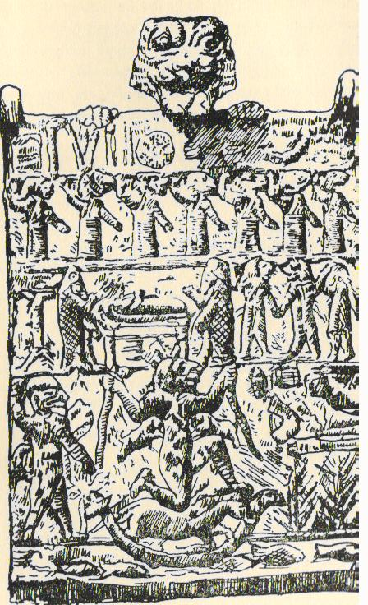

2. High-rise round dance

High-rise round dance from the documentary film Giorgi Salukvadze.

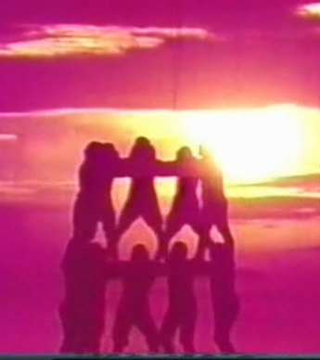

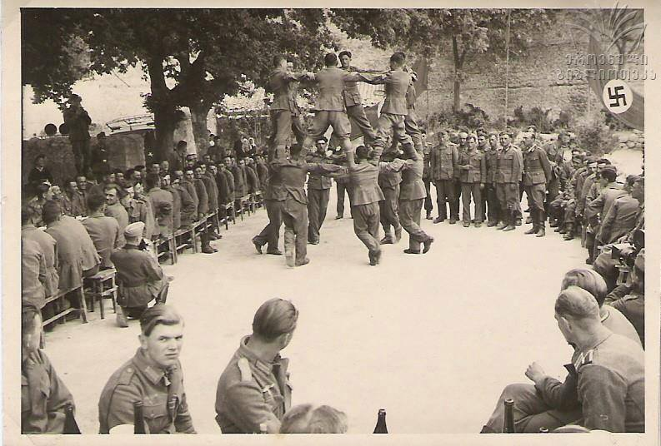
The Georgian Crimea Battalion, 26 May 1943.

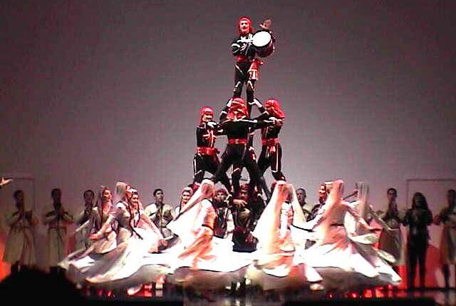

Modern performance (Georgian Song and Dance State Ensemble)

3. High-rise round dances comprise astral symbolism

The form of round dances: All of them are identical

4.
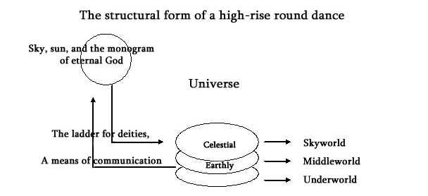

5.
Gurian Round Dance `partsa`

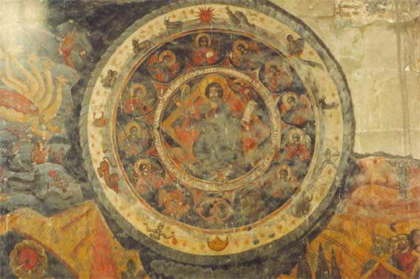
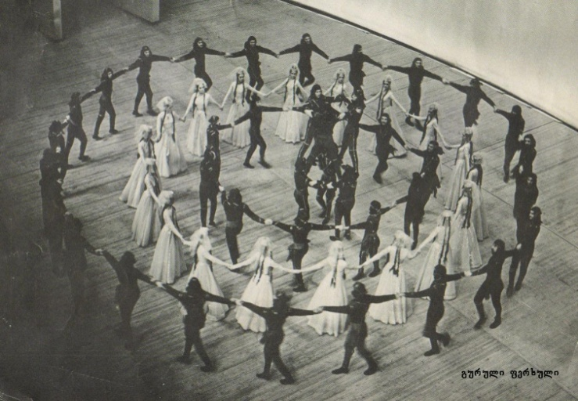
Zodiac, the south wall of the temple fresco

6. Belt (Bronze, 8th-7th centuries BC), Nabaghrevi, Mtskheta District.

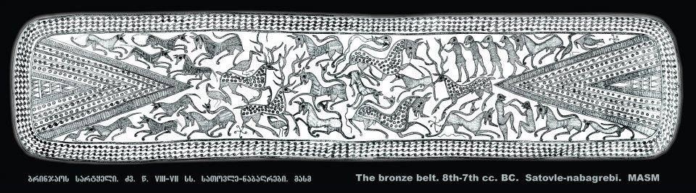

7. Samadlo settlement patterns
Isarna (wine-producing dishes) (4th-1st centuries BC), Samadlo.

Kvevri (wine-producing dishes) from Samadlo, (4th-1st centuries BC)

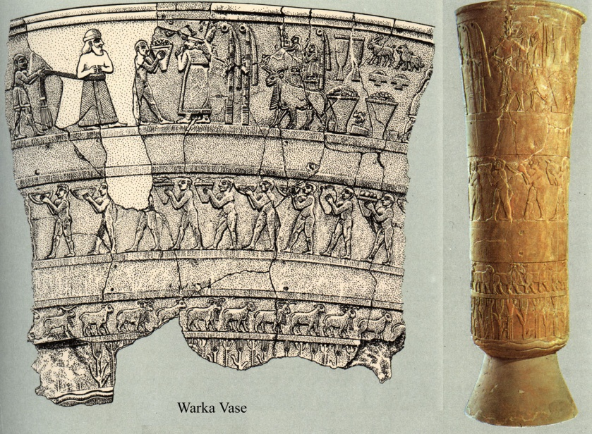
8. Silver cup, Trialeti, 2nd millennium BC. 9. Alabaster vase, Uruk, 4th-3rd millennium BC.
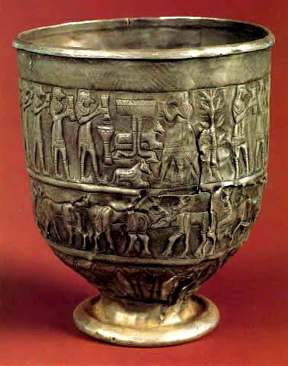
10. The rock-cut relief in Yazilikaya in the village of Bogazkoy (Turkey),
2nd millennium BC.

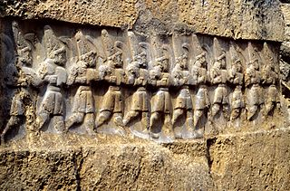

11. Connection of the names of linear round dances with the productivity cult:

12. The genesis of the universe - struggle between the Dragon (chaos) and Griffin (cosmos);
The Tusheti Ethnographic Museum.
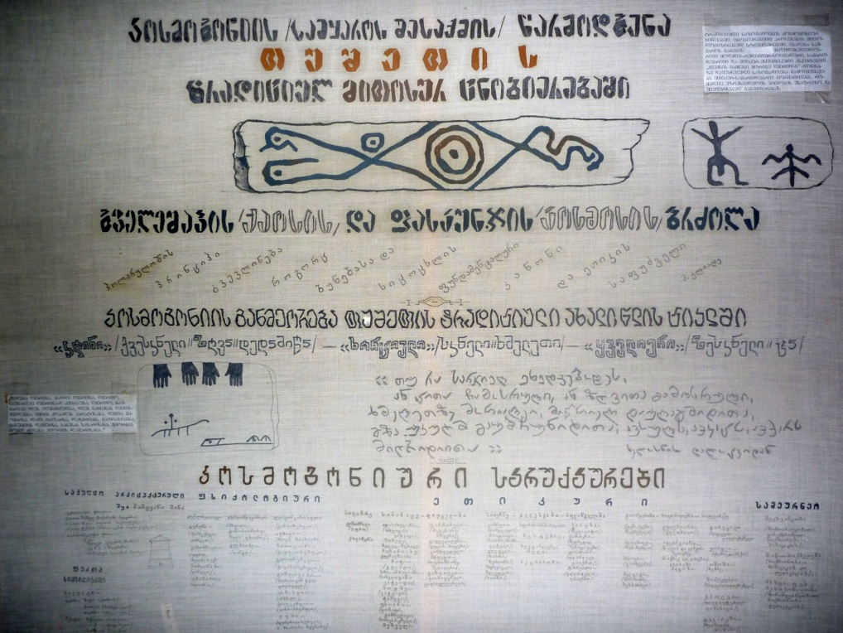

13. Mtskheta. A fresco on the southern wall of Svetitskhoveli restored in the 17th century.

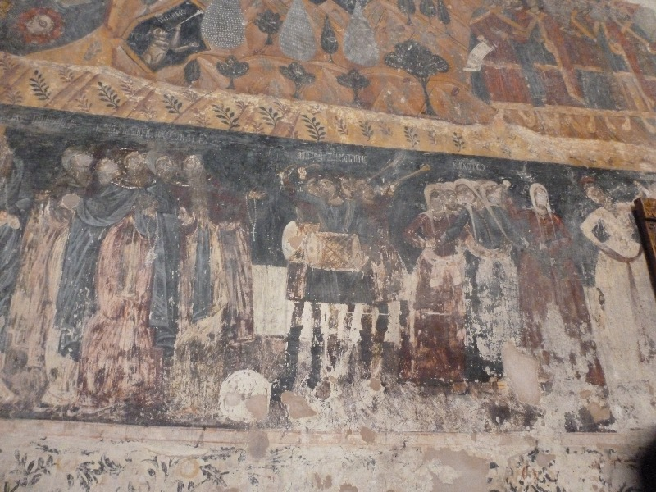

Sketch of the fresco by Gagarin
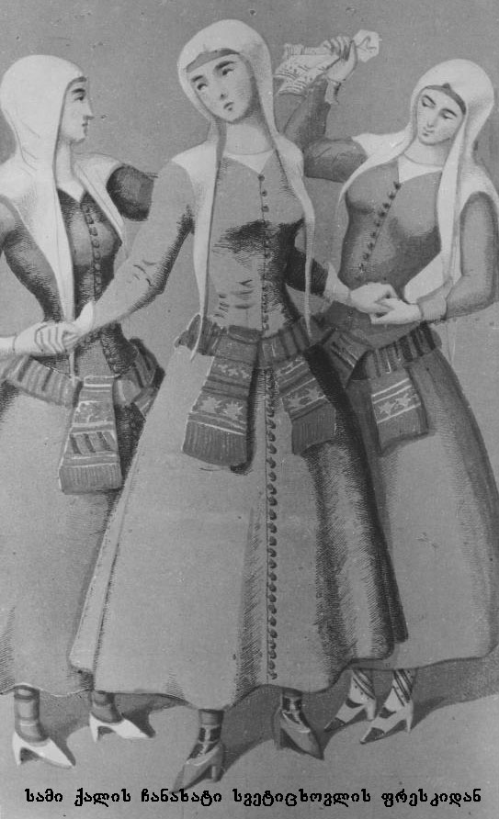

Encyclopedia of ancient symbols, www.sigils.ru
Aniela Jaffe, Symbols in art. http://www.xliby.ru/psihologija/chelovek_i_ego_simvoly/p5.php
Tataradze A., Issues of History of Georgian Folk Choreography. Tbilisi, 1999. (In Georgian) p. 11.
Mythological symbols of ladder and bridge. http://astroblogi.com (In Georgian)
Eliade M., Myths, rituals, and their purpose (Элиаде М., Аспекты мифа. М.,). Chapter III, p.23-29. http://yanko.lib.ru/books/sacra/eliade-aspektu_mifa.pdf (In Russian)
Symbols of Christian Art - Cross, http://www.nplg.gov.ge/gsdl/cgi-bin/library.exe?e=d-01000-00---off-0dictiona--00-1--0-10-0---0---0prompt-10--..-4-------0-1l--11-ru-50---20-help---00-3-1-00-0-0-11-1-0utfZz-8-00&cl=CL1.1&d=HASH011fe8f22372a9af597f36d3.1&x=1 (In Georgian)
Toporov B.N., Numeric code in the plot. (In Russian) Moscow, 2001. -2. p. 348.
Tataradze A., Issues of History of Georgian Folk Choreography. Tbilisi, 1999. (In Georgian), p. 22-23.
Gelovani A. Mythological Dictionary. Tbilisi, Sabchota Sakartvelo, 1983, p . 49 (In Georgian).
Tataradze A., Op cit. p.22.
Pilpani v. Master Class in Svan Folk Dances. Tbilisi, 2008. Personal video archive.
Javakhishvili I., History of the Georgian Nation. vol.I. Tbilisi, 1979, p.55. (In Georgian)
Takaishvili E. Regulations of the Royal Court. Tbilisi, 1920; p 11-12. (In Georgian) (Published by I. Javakhishvili) p. 184. http://www.useug.com/cign/ivane_javaxishvili_qei_5.pdf
Urushadze A. Kutaisi in Greek and Roman Sources. Tbilisi, 1993, p. 17-20. (In Georgian)
Pilpani V. Master Class in Svan Folk Dances. Tbilisi, 2008. Personal video archive.
Bardavelidze V. Examples of Georgian (Svan) Ritual Graphic Art. - Tbilisi, Georgian Academy of Sciences Publishers, Tbilisi,1953. p.130-131. (In Georgian)
Javakhishvili I., History of the Georgian Nation. Introduction. 1950. Vol - 1, p. 185. (In Georgian)
Tsanava R. The Problem of Genesis and Formation of Mythic and Ritual Models. The Journal of the Humanities. 2003, Vol 4, p. 3-17. (In Georgian)
Dixon O., Shamanism, history, theory and practice of indigenous shamanic traditions. Moscow, 2000, p.28-32. (In Russian)
Bardavelidze V. Pshavs of Iori: [Diary. Ethnographic materials]. Messenger of the Institute of Language, History, and Material Culture. Tbilisi, 1941. - Vol.11. - p.67-182; (In Georgian) Georgian Popular Holidays. Newspaper Кавказ. 1878, N230.
The Great Mystery. http://slavya.ru/rites/volh/darksun/sunrit.htm (In Russian)
Surguladze I. Ethnographic Expedition to Mountainous Tusheti. The Foundation for the Protection of the Georgian Ethnographic Legacy. - Tbilisi, 2003, p 11.
Mircea Eliade, sacred and profane, Moscow, 1994. p.36. (In Russian)
Morina L.P. Myth and ritual dance. Religion and morality in a secular world. Herald, conference materials. November 28-30, Petersburg, 2001. p. 122-123. (In Russian) http://anthropology.ru/ru/texts/morina/secular_29.html
Kitaev-Smyk Л.А. Muslim "dhikr" Christian "liturgical circle" dances and solar. (In Russian) http://www.kitaev-smyk.ru/node/7
Natalia Kananovich, About the belts in the Slavic tradition. http://rodonews.ru/news_1279171345.html (In Russian)
Abakelia N. Time and Space as Ornaments in Bronze Artifacts Found on Georgian Territory. Semiotics. https://semioticsjournal.wordpress.com/category/) (In Georgian)
Joost Blasweiler, Hattusa: sacred places near Büyükkaya, Ambarlikaya and the Budakŏzŭ http://www.academia.edu/4231302/Hattusa_sacred_places_near_Buyukkaya_Ambarlikaya_and_the_Budakozu
Oniani A. Lushnu Ambvar, Petrograd, 1917, now kept in the archive of the Ethnography Department of the Javakhishvili Institute of History and Ethnology. (In Georgian)
Gvaramadze L. Georgian Dancing Folklore. Tbilisi,1997, p.21. (In Georgian)
Eristavi R. Notes Svaneti in Notes CBIRG Soc, -19, Tbilisi,1897, p. 106; (In Russian)
Gabliani E. Old and New Svaneti. Tbilisi, GSSR State Publishers, 1925. p.126-127. (In Georgian)
Makalatia S. The Cult of Phallos in Georgia. Observer, the Society of History and Ethnography, Tbilisi,1926. p.23-30. (In Georgian)
Chanishvili L. Ethnographic Memories of Anzor Chankseliani on Telepiai-Meliai. Collection of works, Ekvtime Takaishvili Tbilisi State University of Culture and Art. II, 2004. p. 225-231. (In Georgian)
Bardavelidze V. From History of Ancient Beliefs of Georgians (Deity Barbar-Babar). Tbilisi,1941. p. 104.; (In Georgian) Also: Janelidze D. Popular Origins of Georgian Theatre. Tbilisi,1948. p. 98-99 (In Georgian)
Eristavi R. Georgian Folk Poetry. Tbilisi1872. N3. p.14-16. (In Georgian) Also: Chokheli S. Georgian Wedding Rituals and Poetic Folklore Tbilisi 1990, p.111 (In Georgian); Chelidze G. Georgian Folk Drama. Tbilisi 1987. p. 237. (In Georgian)
Dictionary of Racha Dialect (Materials): Further Kobakhidze A. Tbilisi 1987. p. 85. (In Georgian)
Jorjadze B. Satirical Article in the Khevtapira Village (Story). Tbilisi 1891. N129. (In Georgian) Chokheili S. Georgian Wedding Rituals and Poetic Folklore, Tbilisi,1990. p. 111-161. (In Georgian)
Eristavi R. Georgian Folk Poetry. N 3, 1872. p.13-14 (In Georgian)
Kotetishvili V. Folk Poetry. Tbilisi,1961. p. 25. (In Georgian)
Georgian Poetry, Vol V, Tbilisi, 1987. p. 579-580 (In Georgian)
Kazbegi A. Works. Vol. V. Tbilisi 1950. p. 507-508. (In Georgian)
Folk Poetry.V. Kotetishvili, Kutaisi. 1934. p. 325-326. (In Georgian)
Prince Vakhtang. Hostoric Description. Tiflis, 1914, p.18. (In Georgian)
Jalabadze G. Materials for the Ethnographic Study of Meskheti-Javakheti. Tbilisi 1972, p.31-36. (In Georgian)

